First Challenge

- Launch one EC2 instance using Amazon Linux 2.
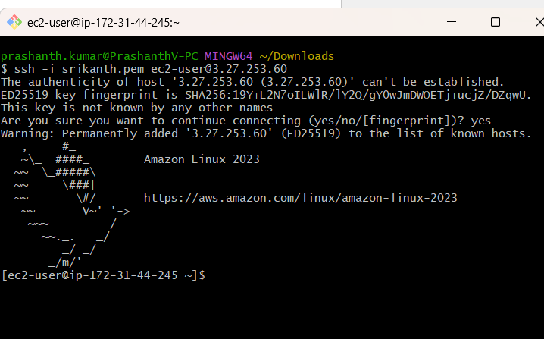
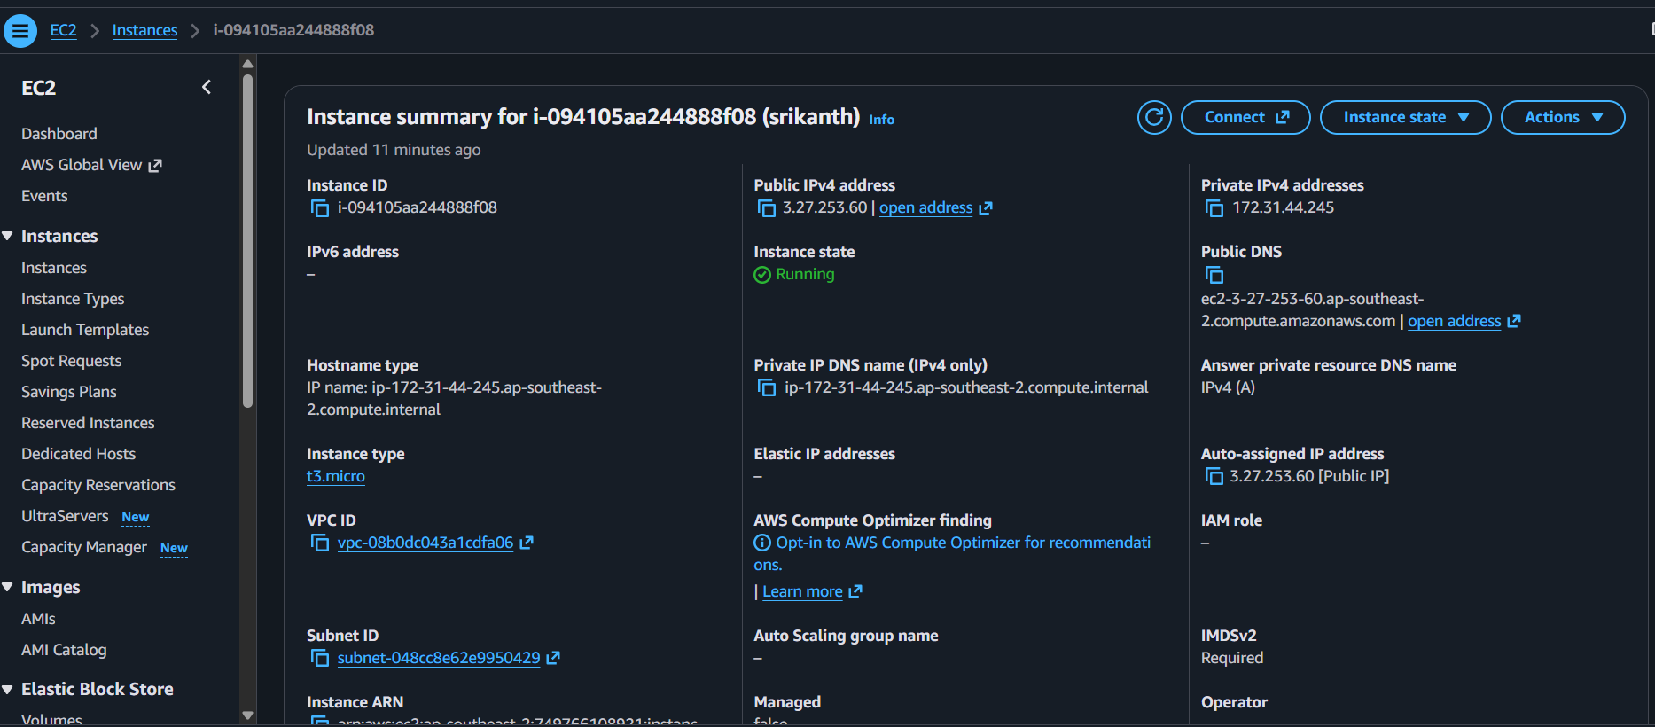

Install Docker.
Steps:
sudo dnf update -y
sudo dnf install docker -y
sudo systemctl start docker
sudo systemctl enable docker
sudo systemctl status docker
docker --version
sudo docker run hello-world

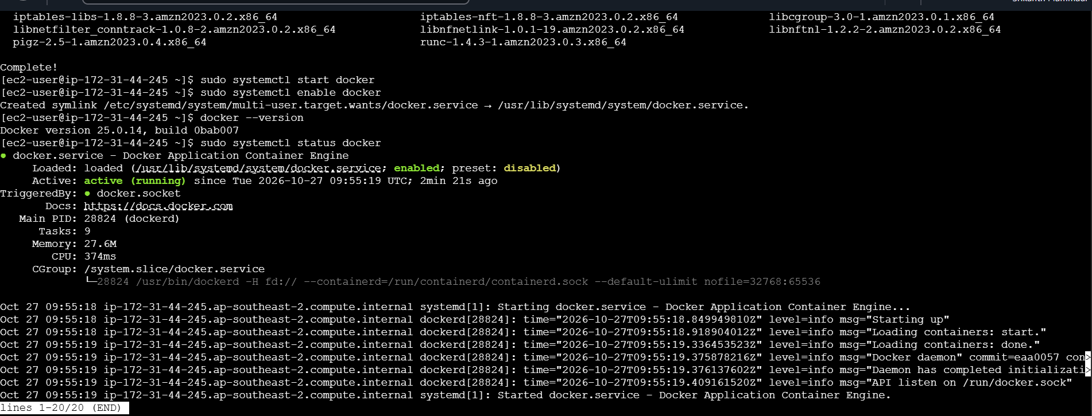

Install Jenkins.

Install and start Jenkins
Sudo systemctl status Jenkins
Sudo systemctl start Jenkins
Sudo systemctl stop Jenkins

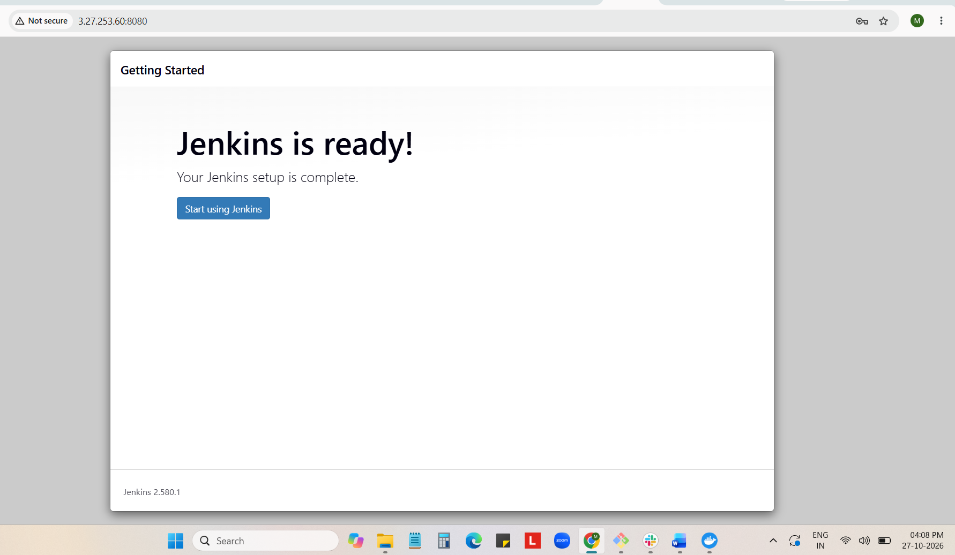

Install Apache.

Install Apache | sudo dnf install httpd -y
Start Apache | sudo systemctl start httpd
Enable at boot | sudo systemctl enable httpd
Check status | sudo systemctl status httpd
Stop Apache | sudo systemctl stop httpd
Restart Apache | sudo systemctl restart httpd

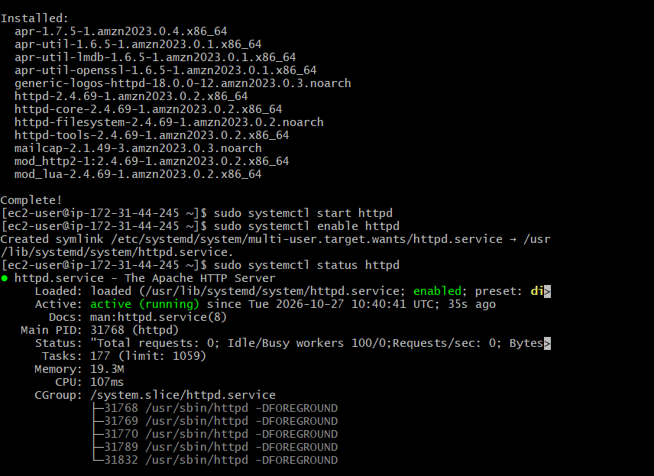

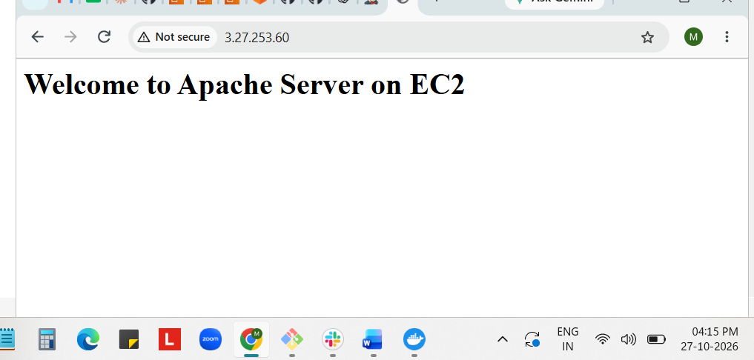

Install Nginx.

Install Nginx | sudo dnf install Nginx
Start Nginx | sudo systemctl start Nginx
Enable Nginx | sudo systemctl enable Nginx
Check status | sudo systemctl status Nginx
Stop Nginx | sudo systemctl stop Nginx
Restart Nginx | sudo systemctl restart Nginx

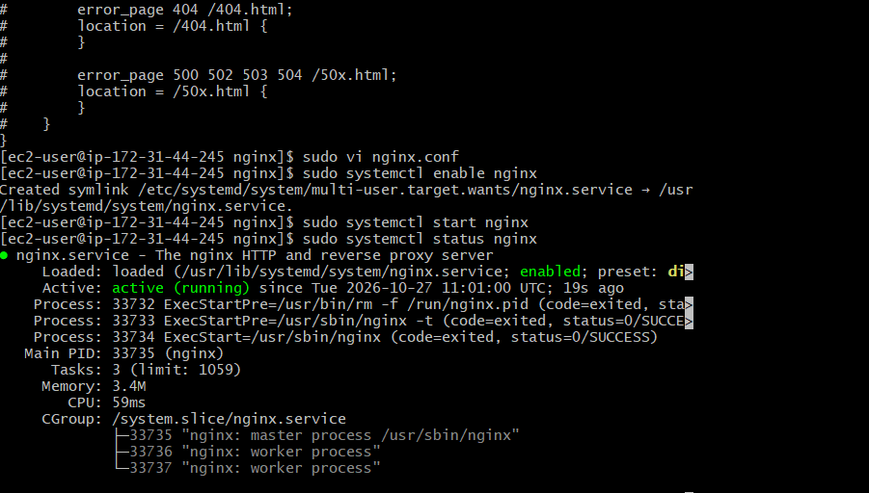

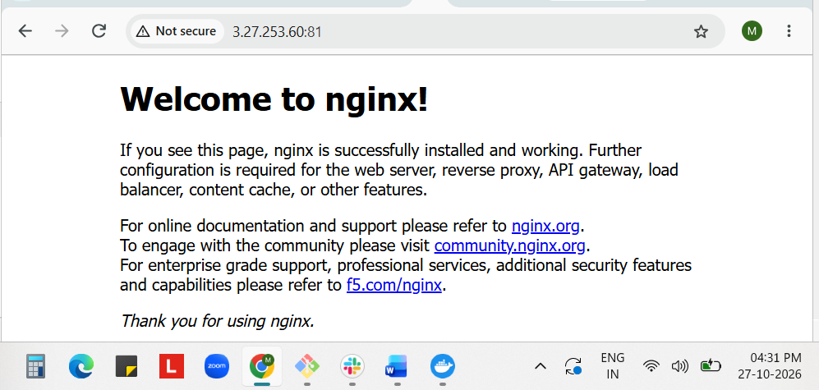

Install Apache Tomcat.

Install tomcat10 | sudo dnf install tomcat10
Start tomcat10 | sudo systemctl start tomcat10
Enable tomcat10 | sudo systemctl enable tomcat10
Check status | sudo systemctl status tomcat10
Stop tomcat10 | sudo systemctl stop tomcat10
Restart tomcat10 | sudo systemctl restart tomcat10

